Keep urgent and minor injury treatment in Burnham On Sea

The Friends of Burnham Hospital

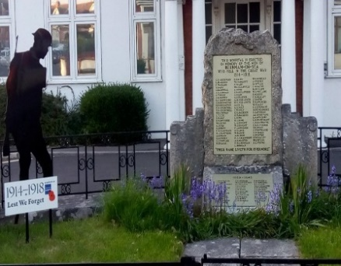 | The NHS are exploring the future of all the Minor Injuries Units throughout Somerset and the establishment of other, fewer, ‘Urgent Treatment Centres’. If Burnham Hospital is not selected as a new UTC it would mean the closure of our MIU and the necessity for long journeys to obtain this type of service, affecting all Burnham-On-Sea residents and visitors, further reducing medical facilities locally.

Burnham-On-Sea has a large proportion of elderly residents who would be greatly impacted by having to travel long distances to obtain minor injury treatment, currently available at the M.I.U. in the Town. Journeys to Bridgwater Community Hospital or Western Hospital A&E would involve hours of travelling using a wholly inadequate public transport system.

During the summer months Burnham-On-Sea attracts thousands of visitors, many with young children. It has been estimated that 20,000 additional visitors a week come to the area and the local M.I.U. then has a big influx of patients, removing this facility would leave a void locally.

The Friends of Burnham Hospital has raised and spent more than £2 million on improving and maintaining facilities at The Burnham-On-Sea War Memorial Hospital, raised through local donations - help us keep medical facilities in the Town.
We, the undersigned, are concerned citizens, who urge our politicians and NHS to act now to retain our MIU or to establish a UTC, at Burnham-on-Sea.

PLEASE SIGN THE PETITION

https://www.friendsofburnhamhospital.org.uk/

Petition to retain Minor Injuries Unit or Urgent Treatment Centre in Burnham-On-Sea
Petition summary and background | The NHS are exploring the future of all the Minor Injuries Units throughout Somerset and the establishment of other, fewer, ‘Urgent Treatment Centres’. If Burnham Hospital is not selected as a new UTC it would mean the closure of our MIU and the necessity for long journeys to obtain this type of service, affecting all Burnham-On-Sea residents and visitors, further reducing medical facilities locally.
Action petitioned for | We, the undersigned, are concerned citizens, who urge our politicians and NHS to act now to retain our MIU or to establish a UTC, at Burnham-on-Sea.

PLEASE RETURN YOUR FORMS BY 24th MARCH 2020 TO ‘THE FRIENDS’, MIU, BURNHAM ON SEA HOSPITAL, LOVE LANE, BURNHAM ON SEA, TA8 1ED or Call 07856213289 to arrange a collection.
Printed Name | Signature | Address | Comment | Date

